

CPqm

User Manual

Developed BY Stefan Schlund  
Beck Tan Wei song

Date September 2016

# Content

1 Intro 2

2 General 2

2.1 Technology 2

2.2 Shell 3

2.3 Navigation & Pages 4

2.4 Routing 5

2.5 Controls 5

2.5.1 Tables 5

2.5.2 Object Selector 6

2.6 Validation 7

3 Details 7

3.1 Login Page 7

3.2 Inbox 8

3.3 Quote Creation 8

3.4 Quote Details 9

3.4.1 General Information 9

3.4.2 Notes 9

3.4.3 Line Items 9

3.4.4 Quote Exchange Rate 10

3.4.5 Attachments 10

3.4.6 Versions 10

3.4.7 Additional tabs 10

3.4.8 Configurator 10

3.4.9 Pricing Page 11

3.4.10 Embedded Mode 12

3.5 User Details 12

3.6 Notifications 13

# Intro

With the new release (1608) the first part of a major rework of the User Interface of the Insight Selling Suite gets introduced. The main goal is to offer a great user experience on all devices – independent of the screen size, input type or browser of a desktop (XL), notebook (L), tablet (M) or smartphone (S). The new UI provides a fast and clear way to support the user fulfilling his tasks. In order to achieve these goals a complete rebuild of the UI source code was required.

The following excerpt describes and illustrates the first phase of the reworked CPQ based views grouped by their context. Although being tested in a regular way the new UI is still in a beta state. Feedback is highly appreciated.

The new UI can be seen when accessing the ISS with the URL appendix index-cpqm.html, for example:

https://hostname/iss/**index-cpqm.html**

# General

New work always gives the opportunity to use new concepts from the ground up as well as to clean up and slenderize the existing source code which helps maintaining and adding new features later on. The following section describes the high level changes and added features.

## Technology

The most prominent change is the exclusive usage of mobile friendly UI elements. The pivotal source of elements is the SAPUI5 mobile library supported by additional libraries if needed. This comes with a couple of benefits like

* Faster response time,
* Lazy loading,
* Quicker initial loading,
* Fully responsive views and
* High compatibility

As an example the time for a light quote import[1] is shown in Figure 1 comparing old (left) and new UI (right).

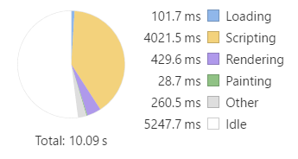 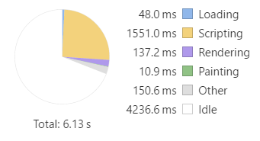

Figure 1 – Comparison of loading times old (left) and new UI (right)

The total time taken should not be a benchmark since the exact call history still differs from old to new UI but the scripting and rendering times are appropriate and prove a noticeable improvement.

Further features like caching and reusing a view to display detail pages help to lower rendering times. For example, in case of switching between objects the view is kept and only the underlying data layer gets replaced. Because of a comprehensive usage of data binding the view gets refreshed automatically.

The implementation of lazy loading, meaning rendering and showing the view before all data are received, supports this impression.

## Shell

As the underlying container the old shell also got replaced by a mobile friendly one. The basic layout changes as a result. The main tabs (Overview, Insights, Accounts …) have been removed to gain more vertical space to work with which helps especially on small screens. A section on the left replaces the tabs as the main navigation. The user can toggle between a detailed and a small version of this section.

The quick creation buttons were moved to the lower part of the left bar as a result.

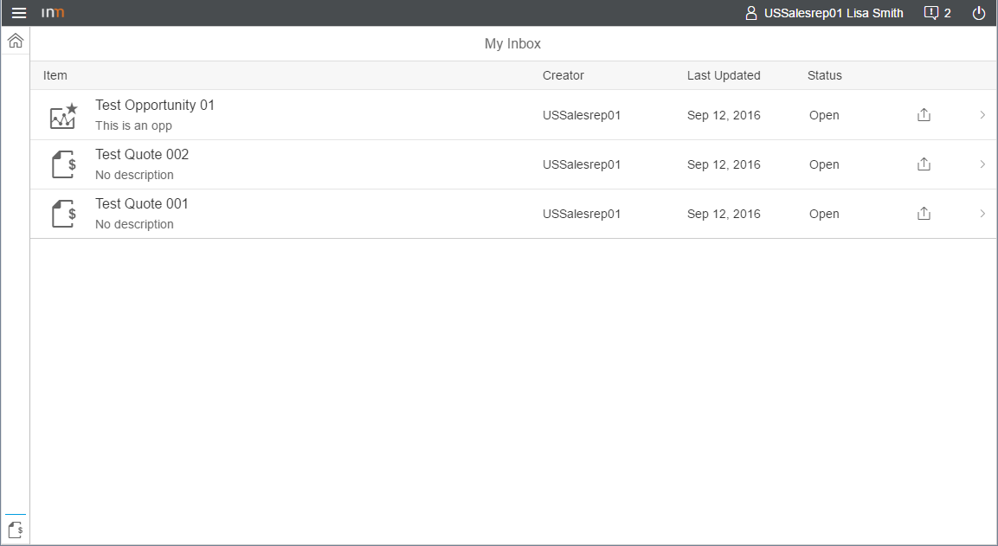

Figure 2 – Inbox page surrounded by the shell

The top elements of the shell (Logo, User Profile, Logout …) retain their position.

The right elements (Search, Product Catalog, Cart) were removed for the time being but could be re-introduced if needed and deemed fit for mobile consumption.

## Navigation & Pages

As a next major change the handling of detail pages was revised. A new detail page doesn’t get opened on top anymore. This also has the negative effect of multiple views stacked above each other and that confuses the user about the order on what was opened before.

The basic components of the new UI are pages. On navigate the previous page gets replaced by sliding in the new page. The user’s view stays at the same level so there are no screen filling overlays. A back button at the top left of a page always allows the user to go the previous page. This navigation concept has been tried and trusted in major mobile operating systems.

**Most of the pages are split into two parts: a master section on the left and a detail section on the right. The master section is displayed for bigger screens as a default but can be hidden by the user at any time by using the full screen button at the top right. For small screens the master section is not shown in the beginning**.

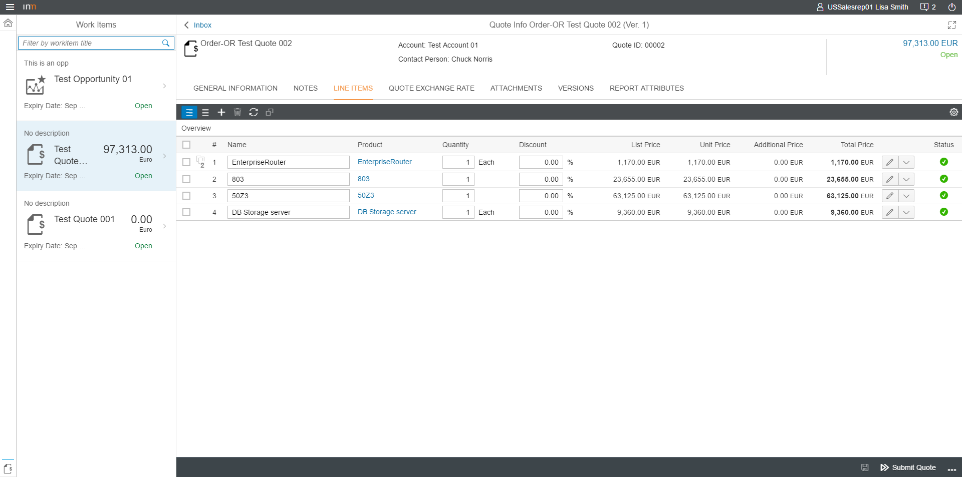

Figure 3 — Quote Details Page

Depending on the current page context the master section shows a selectable list of all available items and their essential information. A search field on top allows the user to filter the list.

The detail section shows the object details content consisting of page header, tabs, tab content and page actions. When using the stand-alone ISS the page actions are located in the bottom right.

## Routing

The new navigation concept also allows us to introduce a related feature: the routing. Every navigation gets also reflected in the browser URL. For example, if a user opens a certain quote the URL gets extended by showing that a quote is open together with the fragment of the quote id and even information which page tab is selected (deep link, see Fig. 4).

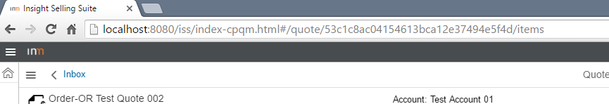

Figure 4 – Routing URL

But not only does the URL follow the navigation. If the user changes the URL the content of the application will also change. This means that the user is able to share a link to a specific quote which would get opened immediately or save bookmarks of important objects.

By having a meaningful navigation history it is also possible to use the browser’s back button to go to previous pages and also to remember the link to objects and share them with team mates.

## Controls

The consistent usage of the mobile library of UI5 also allows us to use new control types which help to increase the user experience. Two examples are described in the following.

### Tables

Tables are used to show plenty of information in a structured way. In numerous sections in the ISS, like the line items table, a lot of table rows and columns are needed to transfer the required knowledge. This requirement is a big challenge on small screens which often ends up in a lot of scrolling or zooming when using a regular table layout. The UI5 libraries offer a good alternative to that: the ReponsiveTable.

A ResponsiveTable provides different options how to show a column depending on the used device or screen size. For smaller screens a table row can be shown in a more compact way by applying a vertical layout (Fig. 5, left) instead of the regular horizontal approach (Fig. 5, right). This helps the user to keep focus on the important information instead of fighting with the unsuitable horizontal UI.

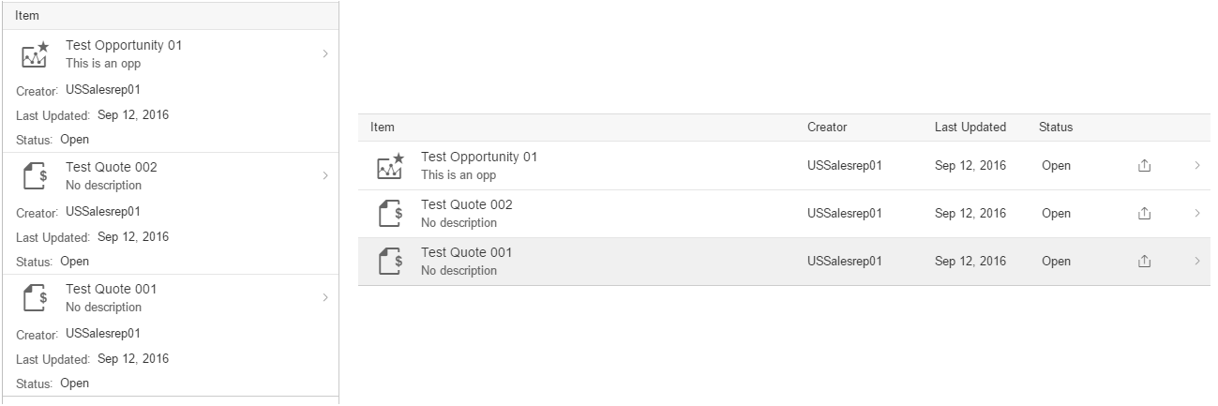

Figure 5 – Comparison of a ReponsiveTable on small (left) and big screens (right)

### 2.5.2 Object Selector

Throughout the application it is often required to choose an object, like contact or product. A regular DropdownBox is mostly inconvenient since it cannot deal with a lot of items or show more detailed information. The old TableSelector partially solved these issues but raised new ones like unfavorable handling and error-proneness.

That’s why a new control is introduced: the ObjectSelector. It is a combination of a TextField with suggestions (Fig. 6, left) and a detailed selection dialog (Fig. 6, right) if necessary. Therefore it is suitable for quick inputs if the user already knows the exact name or detailed searches possibly supported by search and filter options.

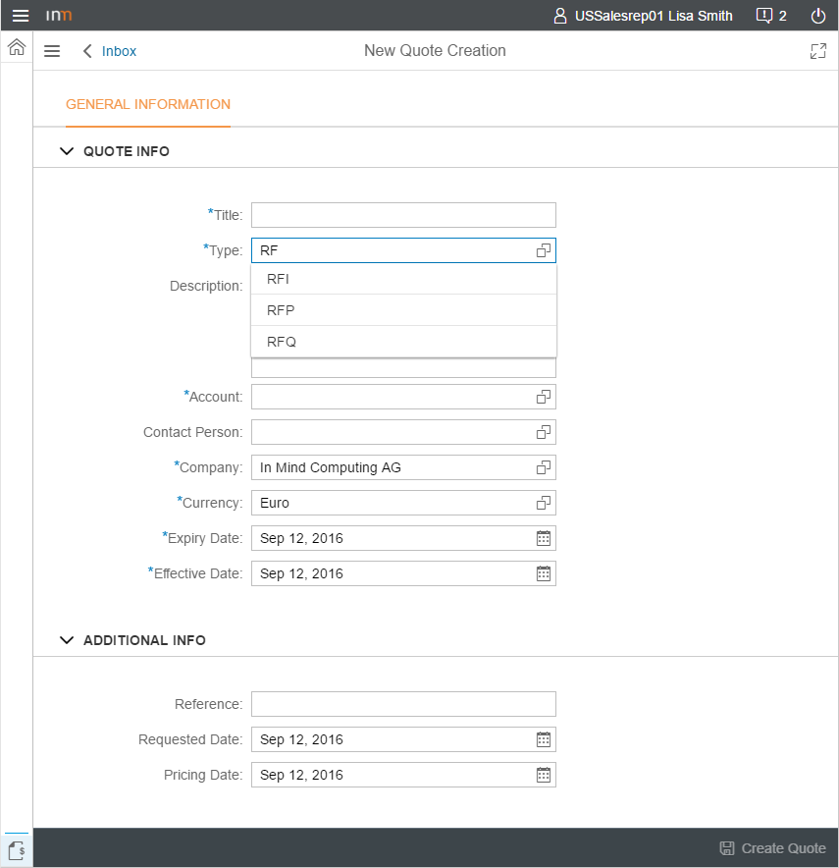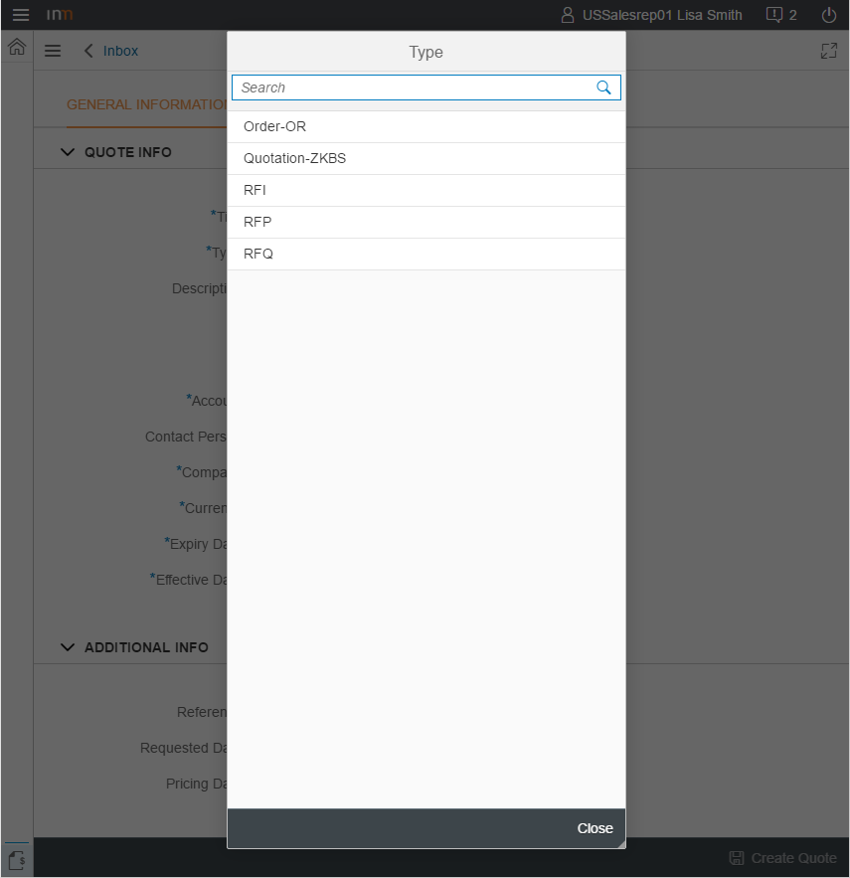

Figure 6 – ObjectSelector as a combination of suggestion list (left) and selection dialog (right)

## Validation

The new UI heavily uses data binding which means that the value of a certain control is actively bound to the data property of a data model. This allows us to use the following validation features provided by SAPUI5:

* Numerous constraint options (range & format of a number, …)
* Automatic error messages next to the control
* Full localization

Certain handlers and callbacks are used to fire an update only if a valid value was entered.

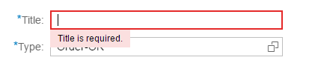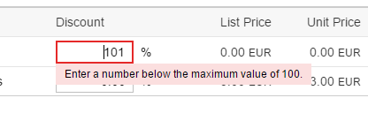

Figure 7 – Validation error messages

# Details

## Login Page

The overall interaction design didn’t change. All controls are based on the mobile library.

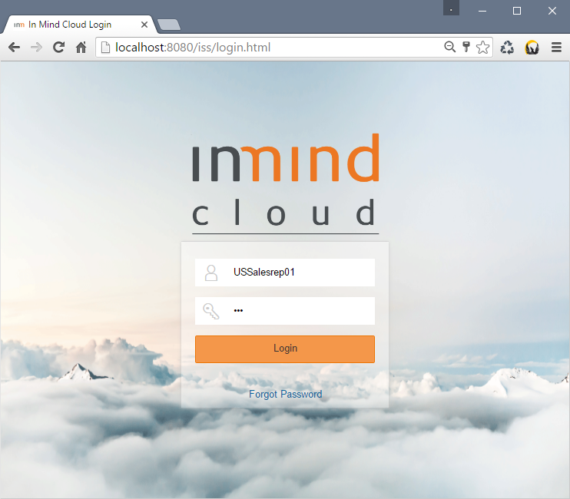

Figure 8 – Login Page

## Inbox

The overall interaction design didn’t change. All controls are based on the mobile library. A few options to filter and sort are not supported yet.

For an image see Figure 2 – Inbox.

## Quote Creation

The quote creation page is accessible via the button in the bottom left side of the shell. The master section lists every existing quote. The detail section is split into important and additional information.

The available attributes are the ones from the old UI plus:

* Description
* Reference
* Requested Date
* Pricing Date

The save button is enabled once all required fields are filled with valid entries.

After a successful creation the user is navigated to the quote details page of the created quote.

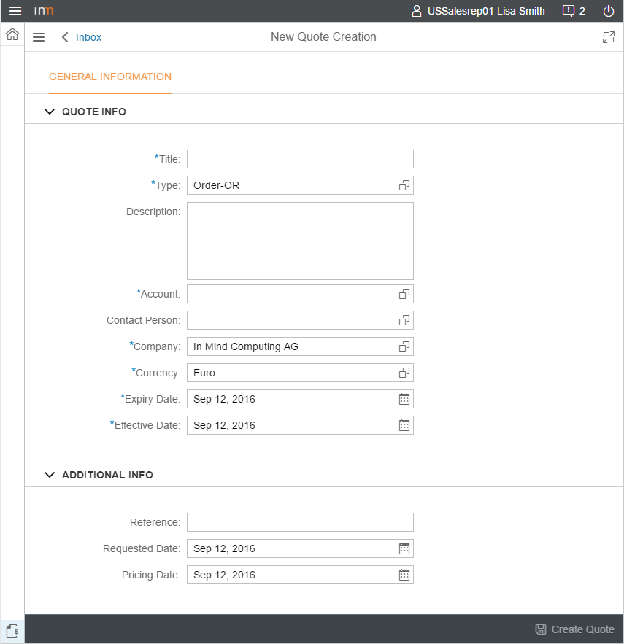

Figure 9 – Quote Creation Page

## Quote Details

For the basic structure of this page please see Section *Navigation & Pages*. An image of the page shows Figure 3 — Quote Details Page. The tabs and features of this page will be described briefly in the following.

### General Information

In this tab all information displayed in the header can be edited along with additional attributes which were in the old UI’s header (e.g. discount).

### Notes

This tab contains the NoteTaker which was placed in the old overview tab.

### Line Items

The line items table received a few notable changes. Previously, this used to be a TreeTable where the user could expand/collapse all levels independently. Since there is no mobile friendly representation in the control pool it was needed to come up with a different approach.

The main idea is to show a list only of these items which are on the same level. This means that initially all parent line items are shown. A click on one line item navigates to the next level which shows all children of the selected item. Breadcrumbs above the table reflect the navigation path and allow jumping back to previous levels easily.

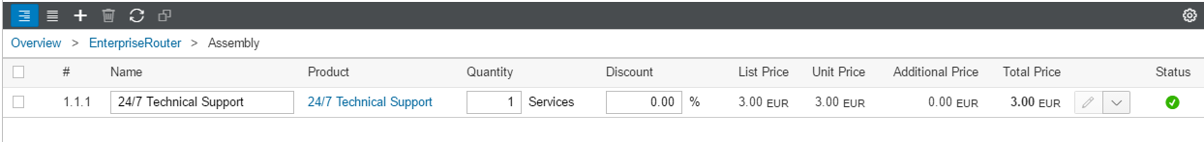

Figure 10 – Breadcrumbs above line items table

There is also a flat view available which shows all line items. In this case their hierarchical level can be seen in the position column. The flat view is also used when the table is sorted or filtered via the TableCustomizer.

The configurator can now be opened with a click on the edit button ( ) in every row. Further actions (edit optionals, tags …) can be accessed via the additional options of the edit button. The features for editing line item attributes, like validation or applying changes to all children, are still present.

Adding a line item can be performed by using the add button. If an existing line item gets selected beforehand the new line item gets created as a child of the selected item – else a parent item is created (same behavior as before). The product selection dialog was improved to load only a limited amount of items initially. When scrolling down the next set of items gets loaded. Selecting multiple items was simplified because the selection sticks even if the user searches for another product in between.

The drag and drop feature was dropped due to its incompatibility to mobile devices.

### Quote Exchange Rate

The overall interaction design didn’t change. All controls are based on the mobile library.

### Attachments

The overall interaction design didn’t change. All controls are based on the mobile library.

Adding attachments is not supported yet.

### Versions

The overall interaction design didn’t change. All controls are based on the mobile library.

### Additional tabs

This view is based on the same control as the configurator, hence supports the same features (validation, lazy loading, grouping… – see section Configurator for details).

### Configurator

The configurator opens as a full size page. The master section contains all **editable** line items of the current quote as a flat list. The detail section shows all configuration item attributes (cstics) of the selected line item. Each group of a configuration item gets shown as a tab. All tabs are placed below each other. A tab selection is in fact a scroll command to the respective tab. For small screens the tab list gets condensed to a DropdownBox containing all tabs as an item.

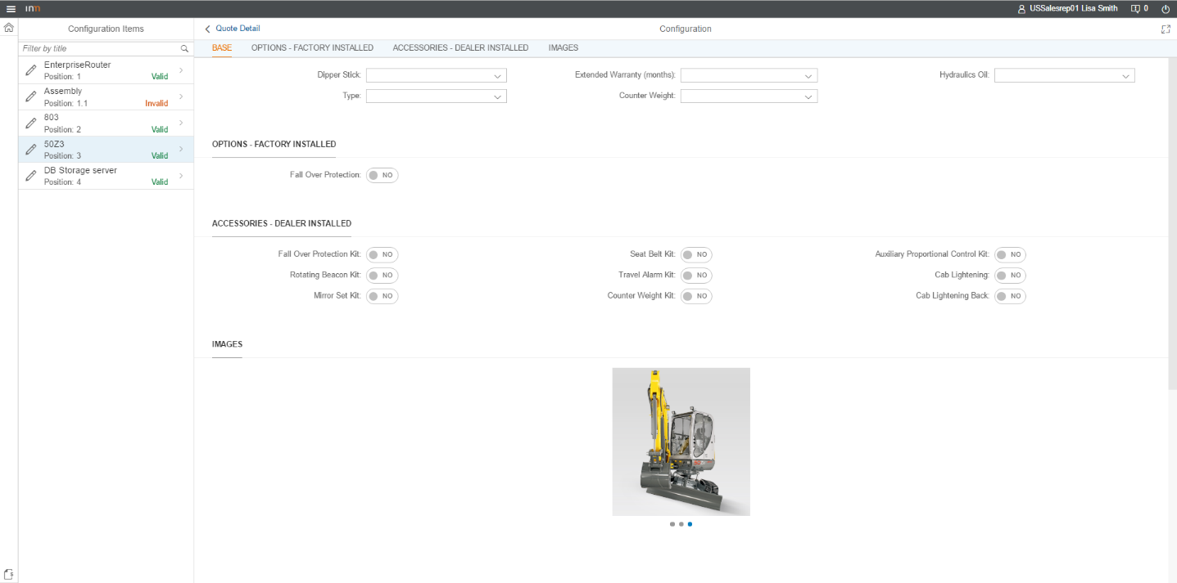

Figure 11 – Configurator Page

Loading the value domain of DropdownBoxes/ListBoxes on select was kept.

### Pricing Page

The pricing page gets opened if the total quote price in the quote header gets clicked. The master section lists the quote as an item as well as all line items of that quote. The header of the detail section shows basic information and the tabs for pricing and delivery details. Every tab contains a table where price items can be added and removed.

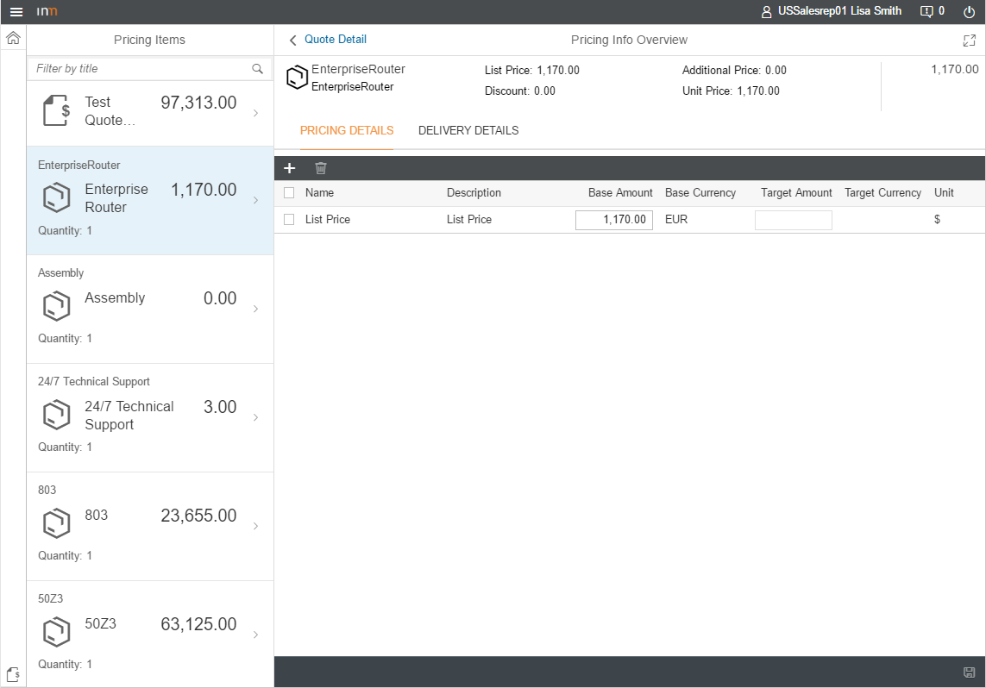

Figure 12 – Pricing Page

### Embedded Mode

The new UI also supports an embedded mode for Cloud for Customer usage. This mode hides the left navigation bar as well as the logout button. Additionally, the quote related actions can be found in the top right instead of the bottom. This is to prevent confusion with Cloud for Customer’s action placement.

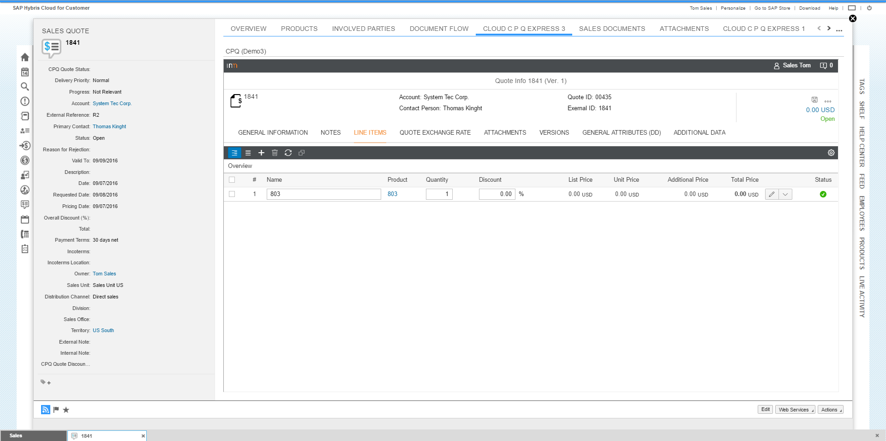

Figure 13 – Embedded UI in Cloud for Customer

## User Details

The overall interaction design didn’t change. All controls are based on the mobile library.

Both tabs (personal details and preferences) were kept. The save button is enabled once all required fields are filled with valid entries.

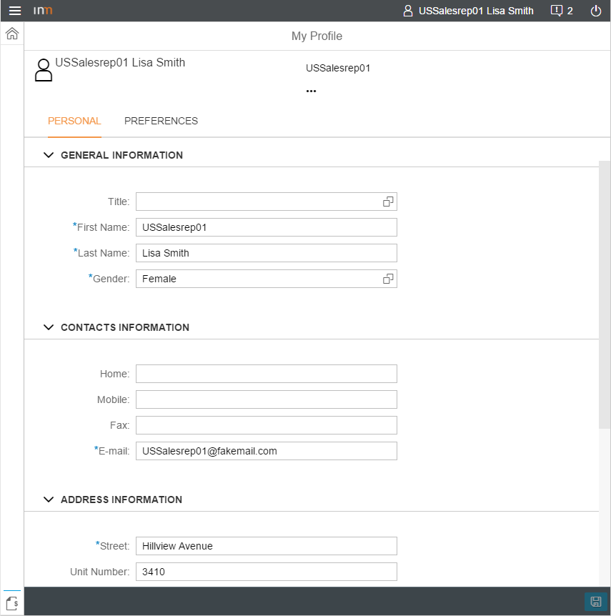

Figure 14 – User Profile Page

## Notifications

The notification bar of the old UI was removed. It got replaced by a notification center accessible with the top right button in the shell header. When collapsed the count of unread notifications gets shown. A red font indicates an error. When expanded the notification center lists all notifications. A selection shows further details and, depending on the notification, related actions. An edit mode allows to remove specific notifications.

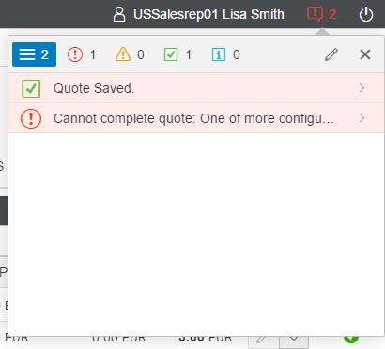

Figure 15 – Expanded notification center

Major errors get shown as a dialog. They also appear in the notification center.

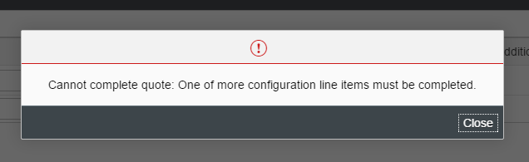

Figure 16 – Error message dialog

1. The test was performed on local with re-importing Quote 1253 in both UI’s.